**Diet tracker**

**Group 4 – Pavan Kumar Malladi and Preeti Moda**

**Introduction:**

The vision of ubiquitous computing is to thoroughly integrate the information processing into everyday objects and activities. According to Mark Weiser, the father of ubiquitous computing, computers would disappear in near future and they would be replaced by mobiles and smaller hand held machines. All these knowledge advantage machines would be built using the three circles of computation, connectivity, intelligence. With the inspiration from Mark Wieser’s view we have developed an application known as “Diet Tracker” which adheres to the concept of three circles.

Now-a-days everyone wants to lead a comfortable life making the best use of technology, and the technology today has ability to bring everything to you in no time. Due to the impact of technology man’s life became sedentary which in turn leads to health abnormalities in him. A combination of excessive calorie intake and lack of physical activity causes obesity and other bodily disorders. There is a great to need to keep a check on food habits and physical activities in our day to day life. We have developed a Google phone application know as “Diet Tracker” to keep a check on the activities that a person is doing and calculate the amount of calories he or she has to take per week to keep oneself fit throughout.

Our application helps the user to calculate his/her Body Mass Index using the parameters such as sex, height, weight .These parameters are given by the user as soon as he/she logins. Based on these parameters our app calculates the body mass index and informs the user about his/her physical condition and also number of calories he/she has to take per week to keep good health.

Next the user can select his option for food or for fitness. Based on his selection he is shown a list of food items and their calorific values per serving. If he selects food option, the user has to enter all the items he has taken during the day or week. These calorific values gets recorded in his profile as soon as he makes a selection. If the user wants to record the information regarding his physical activities he has to select the fitness menu where he is redirected to a separate menu where all the activities are listed along with the amount of calories that can be burnt by doing that activity. The user has to make the appropriate selection to reflect the physical activity he has done in the week. The amount of calories he has burnt is recorded in his profile.

The user can view his calories statistics by navigating to statistics page through menu. Here, the user is shown a bar graph of the amount of calories he has burnt and amount of calories he has taken per week and the amount of calories that have to be taken by the end of week are neatly presented. Using this graph the user can keep track of his food and physical habits thorough out the week. We have also provided help menu in the application which gives some helpful suggestion to the user based on the input he has given.

**Technologies used:**

--Eclipse and built in android emulator, Android SDK, SQL Lite database, html.

Android is a mobile operating system running on the linux kernel. Android has provided an SDK to program the applications in android supported mobile. We used eclipse as editor for our project.

To develop the user interface we have used android linear and tabular layouts using this one can build a user friendly interactive user interface. Our user interface accepts only legitimate values when the user enters his information as soon as he logins to our app.

To maintain the profiles of each user we have created a database using ‘SQL Lite’ provided in the android emulator. SQL lite provides commands to create a database and tables. It also provides functions to insert, update the data by reading the input the user has provided.

Graphics package in android is used to graph the calorific values by extracting the information from the database based on the person who is logged in.

**Enhancements:**

1. A pedometer can be attached to the mobile and connect it to the application to calculate the amount of distance walked or jogged by a person based on the number of footsteps. This information is logged into the database and is also reflected in the statistics graph. Using this, the user need not to enter the information manually each time he has done some work.
2. A barcode reader can also be programmed in the application so that whenever user shows the bar code reader of the item he ate the information entered into the data base so that the user need not worry about the keying of the information of the item and the quantity he ate.
3. A network of sensors can be maintained with the user and his personal doctor so that the sensors in the mobile keep track the parameters such as temperature, pulse rate, blood pressure and informs to the personal doctor mobile. Thus, the physician can constantly keep track of his patient condition though he is away from him. He can also recommend some diet or necessary physical activities to the patient accurately and promptly.
4. RSS Feeds of (as done by group 1) can also be integrated into our application to get the updates and tips from some health related websites and portals. The user can subscribe to certain health tips on his interest and get them delivered to him into his G phone, so that he never misses any tip.
5. The entire information (say for a period of 6 months) of the user can be recorded and his calorie intake must be checked and based up this information our app can also suggest some food items to be taken to avoid any kind of imbalance in the diet.

**Three circles:**

The above discussion regarding the transformation ofan entity into a knowledge advantage machine has three characteristics-Intelligence, connectivity, computation. Our app has some amount of intelligence as it maintains information belongs to the user, in simple terms it knows who you are. Computation is done in the backend based on the input provided by the user. Communication is included in providing the weekly statistics.

**Screenshots:**

The screenshots have been taken to give a better understanding of our project. 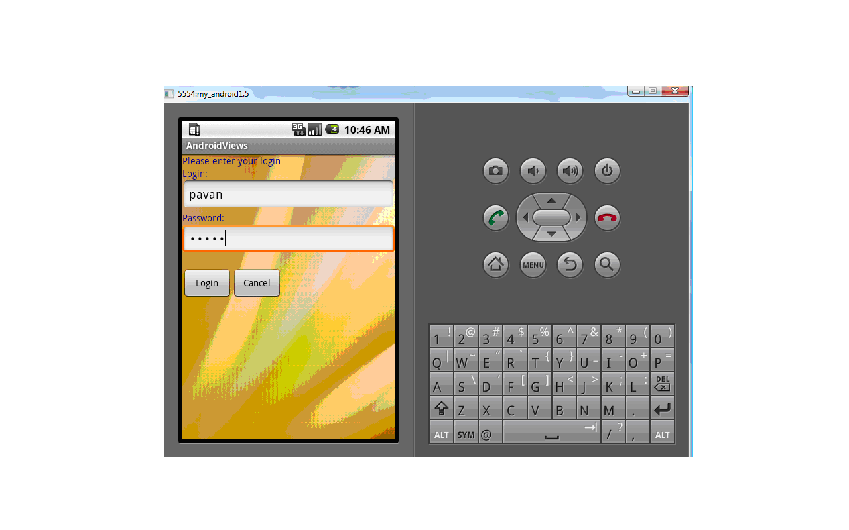

The above screenshot is of the login page. When userid and password are entered ,the user can get into the main page.

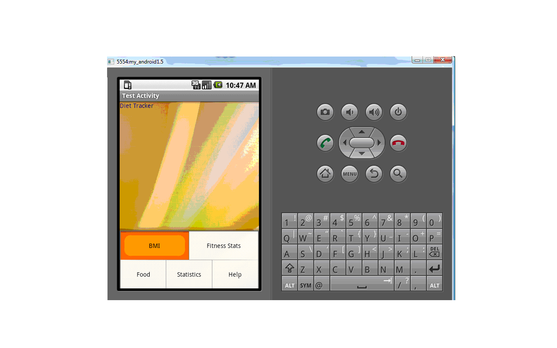

This is the screenshot of the main page. It has five options in the menu. BMI, Fitness Stats, Food Statistics and Help.

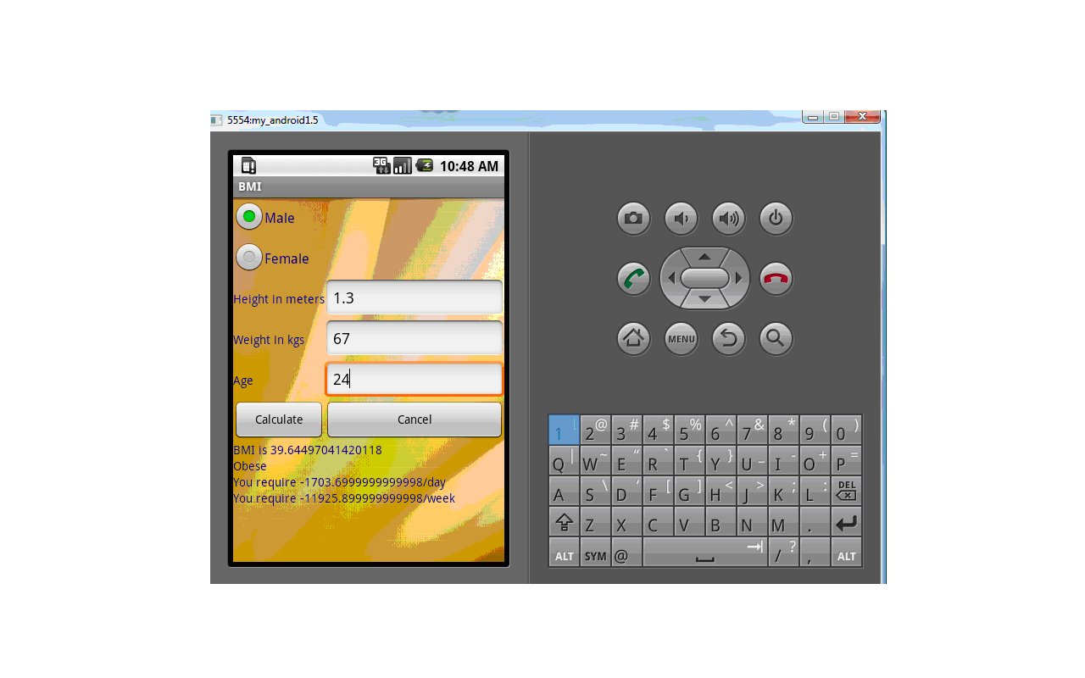

This is the screenshot of the BMI page. Here the details are entered and BMI can be calculated. Also calories that have to be consumed per week are also displayed.

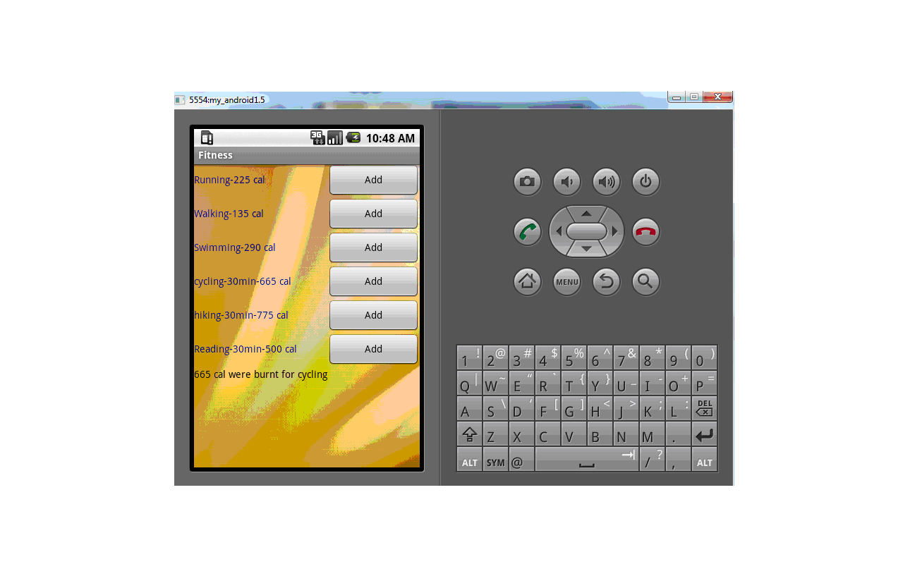

The above screenshot is obtained from clicking the fitness icon. Here calories that are burnt by performing a particular physical activity can be entered in the database.

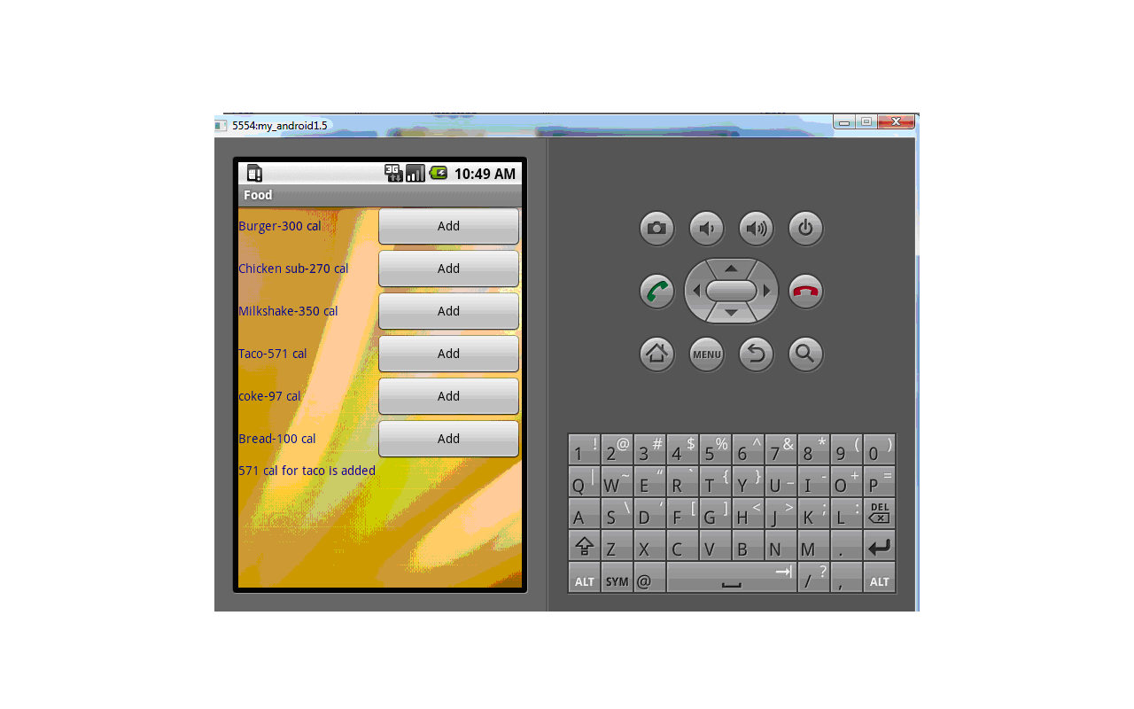

This screenshot is of Food entries. When we click on a button corresponding food item’s calories are entered in database.

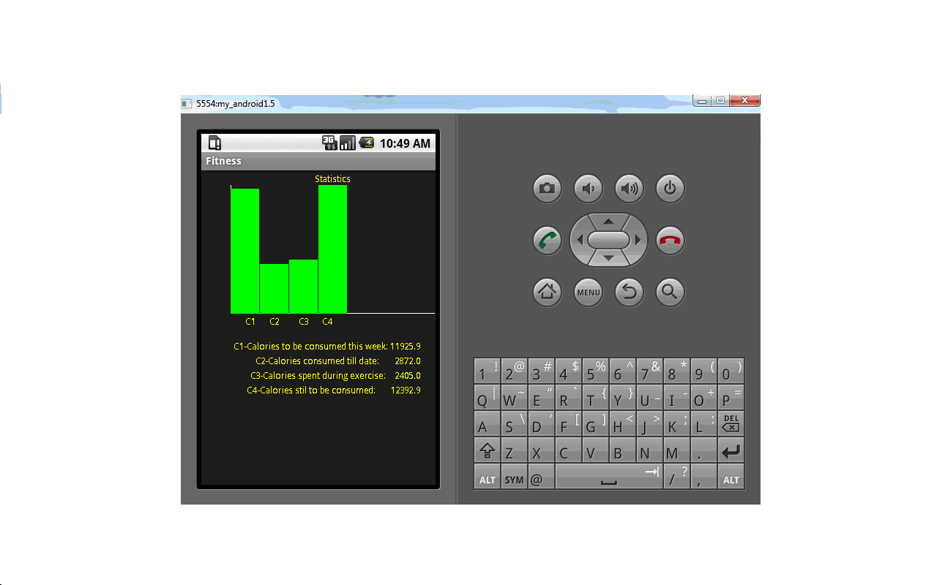

This is the statistics of the calories being spent and consumed per week.

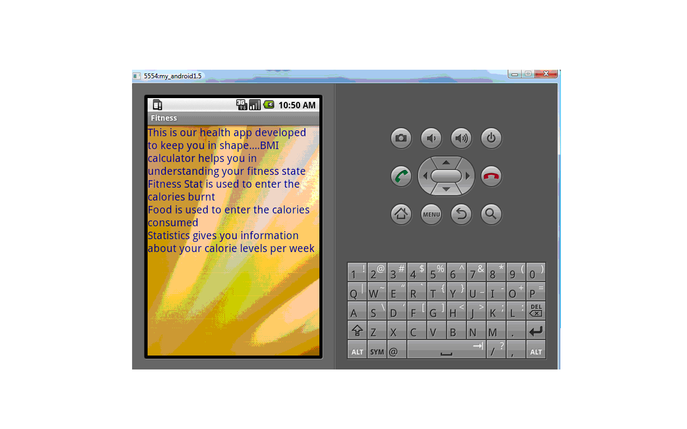

This is the help page which gives information about our app.

**Conclusion:**

Our project is a basic prototype which implements the functionalities of a health application on a mobile phone. Many more features can be added to this app to make this a better app like pedometer etc.